CC-215-L: Database Systems Lab
BS(IT) - 2024
LAB _04

The objective of this lab is to:
- Decode
- Case
- Group functions,
- Revision.
Course & Lab Instructor: Dr. Asif Sohail
Hope you are fine and feeling yourself comfortable and exciting to play with Structured Query Language (SQL) in this first lab.
You have been taught in the lecture about SQL and query writing. Why not to get all what you have learned with a hands-on experience? So, let’s Start!
Allowed time: 1 hour 10 mins
Note: Do follow these instructions while you are sitting in the lab and performing the tasks.
- Gossips are not allowed. So be gentle and do what you know. The lab is not to deduct your sessional marks but to prepare you to achieve good marks in quizzes, mids and finals and finally have good grades. So, try to perform all your tasks in time and at your own.
- Teacher assistants are for your help, so be nice with them. Respect them as they are teaching you. Raise your hands if you have some problem and need help from TA. Avoid calling them by raising your voice and disturbing the environment of Lab.
- You must revise the content of the past lectures before starting the lab, it will help you resolve most of your general queries and give you the confidence that you can do it.
- Evaluation will be considered final and you cannot debate for the marks. So, focus on performing the tasks when the time is given to you.
- TA may deduct your marks for any kind of ill-discipline or misconduct from your side.
- Finally, pray before you start. And, Best of Luck!

- Kindly paste the query as well as result table screenshot as a result of each task
Sample:
Display All the Employees from emp table
Solution:
Select * from emp
EMPNO | ENAME | JOB | MGR | HIREDATE | SAL | COMM | DEPTNO
7369 | SMITH | CLERK | 7902 | 12/17/1980 | 800 | - | 20
7499 | ALLEN | SALESMAN | 7698 | 02/20/1981 | 1600 | 300 | 30
7521 | WARD | SALESMAN | 7698 | 02/22/1981 | 1250 | 500 | 30
7566 | JONES | MANAGER | 7839 | 04/02/1981 | 2975 | - | 20
7654 | MARTIN | SALESMAN | 7698 | 09/28/1981 | 1250 | 1400 | 30

Task 01: [10 Marks]

- Display the employees who have at least 3 employees working under them.
- Retrieve the median of the highest salaries earned in each department.

- Display ename, and salaries of the all employees and determine weather their monthly salaries are even or odd.
- Write an SQL query to classify employees into different experience levels based on their hire date. The classification should be:
- Senior: Employees hired on or before December 31, 1982
- Mid-Level: Employees hired between January 1, 1983, and December 31, 1987
- Fresher: Employees hired on or after January 1, 1988
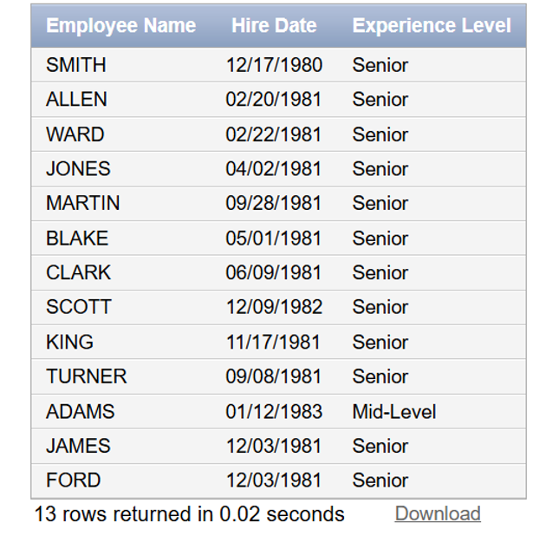
- Write an SQL query to determine the office type of each department based on the deptno (department number) using the DECODE function. The department office types are assigned as follows
- Department 10 → "Head Office"
- Department 20 → "Regional Office"
- Department 30 → "Branch Office"
- Any other department → "Unknown Office type"
- Write a query to display the employee names (ENAME) such that each character in the name is repeated twice consecutively.The output should show the original name and the transformed name in two separate columns. For example:
SMITH → SSMMIITTHH
ADAMS → AADDAAMMSS

- Find the percentage of the number of employees receiving commission

- Display the names of employees who work in Department 30. Divide their salary by 5.2. Answer should only have 3 numbers after decimal point. Name the column “Rounded”.
- Display EMPNO, ENAME, JOB, SAL, deptno, Dname of all the employees. Use Decode function to map deptno to the corresponding dname available in the dept table.
- Write a query to display the student names (STD_NAME) from the PUCIT table such that the case of each character is toggled:

Task 02: [20 Marks]

- Count employees with commission, without commission, and NULL separately

- Find department-wise highest and lowest salary

- Display employees grouped by whether salary is odd or even
- How many Employees are there who are manager and earn more than 2500
- Write a query that uses ROLLUP to calculate the number of employees and sum of their salaries working under a certain manger. Sort the output in desceding order by the number of employees.
- Show the sum of salaries but replace with label if it exceeds 10000
- Find total employees per job and show whether the job is “Single Employee Role” or “Multiple Employee Role”

- Reverse the string “SQL is love”
- Each employee saves 10% of their salary every month. Write a query to calculate the number of months required for each employee to save a total of $2,500. The output should display the employee name, salary, and the number of months needed. Round up fractional months to the next whole month.

- Use CUBE to show department/job totals and grand total
Task 03: [15 Marks]
Question 01: Write a query to display name, hiredate, service time (in years), status of employees. The service time should be rounded. Status will be "Gold", if the years of service is greater than 40. Otherwise, the status will be "Silver
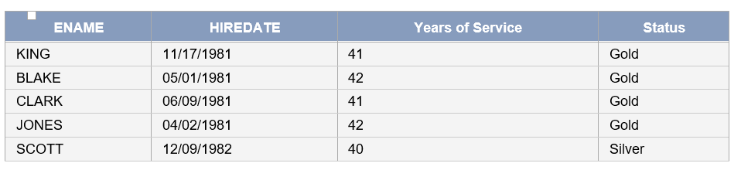

- Question 02: Display empno, ename, job, sal, tax, net sal. The tax is computed using the following tax slabs:
SAL | TAX RATE (% of sal)
Below 1000 | 0%
1000-1499 | 5%
1501-1999 | 8%
2000-2499 | 10%
2500 and above | 12%

Question 03: Write an SQL query to display the employee name, salary, and a visual representation of their salary using asterisks (*).
Each asterisk should represent one thousand in the salary, such that:
Salaries less than 1000 are shown with 1 asterisk (*)
Salaries from 1000 to 1999 are shown with 2 asterisks (**)
Salaries from 2000 to 2999 are shown with 3 asterisks (***), and so on.

Task 04: VIVA QUESTIONS [5 Marks]

